May 10, 2018, 06:18am

**Blockchain Used To Track Gems To Counter Blood Diamonds And Fakes**

<https://www.forbes.com/sites/tobyshapshak/2018/05/10/blockchain-used-to-track-gems-to-counter-blood-diamonds-and-fakes/#f45c64718f67>

[[](https://www.forbes.com/sites/tobyshapshak/)](https://www.forbes.com/sites/tobyshapshak/)

[**Toby Shapshak**](https://www.forbes.com/sites/tobyshapshak/)Contributor

*I write about how innovation is better in Africa.*

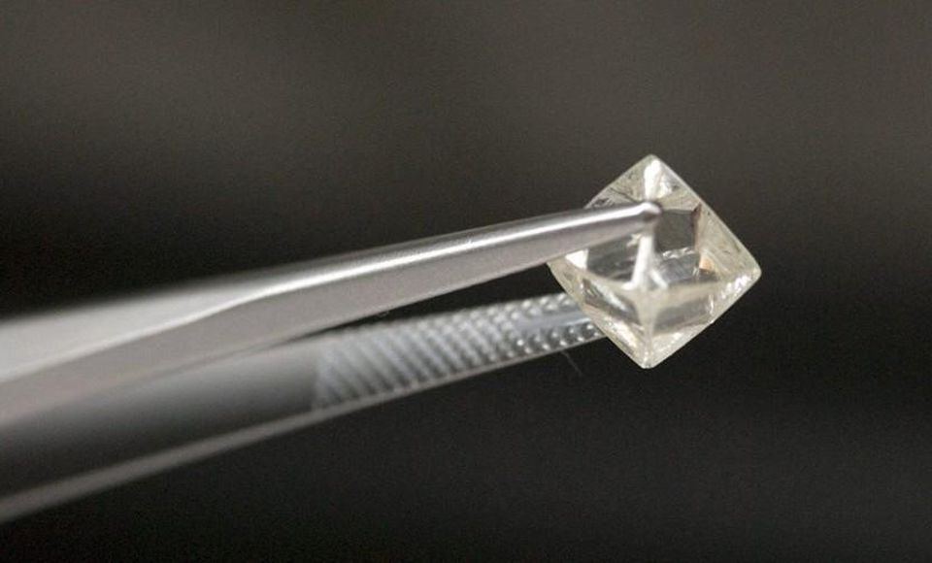

Blockchain is being used to track diamonds.DE BEERS

Blockchain technology has been used in a pilot project to track diamonds from the mine to retail by South Africa’s De Beers Group, the world’s largest producer of diamonds.

The company has tracked 100 high-value diamonds along its entire value chain using an “immutable and secure digital trail [that] was created for a selection of rough diamonds mined by De Beers as they moved from the mine to cutter and polisher, then through to a jeweller” it said in a [statement](https://www.debeersgroup.com/en/news/company-news/company-news/de-beers-group-successfully-tracks-first-diamonds-from-mine-to-r.html).

De Beers calls its Blockchain platform Tracr, which it says will be open to the industry when it launch later this year. The pilot was launched in January.  “When fully operational, Tracr will provide consumers with confidence that registered diamonds are natural and conflict-free, improve visibility and trust within the industry, and enhance efficiencies across the diamond value chain,” it said.

“The Tracr project team has demonstrated that it can successfully track a diamond through the value chain, providing asset-traceability assurance in a way that was not possible before,” said De Beers Group CEO Bruce Cleaver. “This is a significant breakthrough made achievable by the close engagement of the pilot participants who share our commitment to industry progress and innovation. We look forward to sharing the platform with more partners in the coming months and capturing their insights before ultimately making this technology available to the broader industry.”

De Beers said it partnered with five leading diamond manufacturers: Diacore, Diarough, KGK Group, Rosy Blue NV and Venus Jewel.

I write about how innovation is better in Africa. I define innovation as solving problems, like the real problems we have in Africa. And solving those problems, solves them for the rest of the world. Africa isn’t just mobile-first, it’s mobile-only. I spoke about this at TED...

[**MORE**](https://www.forbes.com/sites/tobyshapshak/)

Shapshak is editor-in-chief and publisher of [*Stuff magazine*](http://www.stuff.co.za/). Based in Johannesburg, his [*TED talk*](http://go.ted.com/bha8) on innovation in Africa has had more than 1.4m views.